Cost of Distribution Study: an economic assessment of the impact of increased road freight taxes on consumer prices

A Full Circle Economics (FCE) Report

Executive Summary
An increase in fuel duty is a potential policy that may be implemented in the upcoming budget. The potential impacts on consumer prices include both direct increases to fuel prices, but also further price rises caused by higher supply chain costs rising throughout the economy, as road freight companies pass on the higher fuel costs they face.
The majority of final consumer price impacts will be felt through higher petrol prices directly faced by the households. However, there are significant impacts felt through both higher food and drinks prices and also higher household energy costs.
A specialised methodology has been developed to assess the overall impacts whilst providing a decomposition of how the impacts are broken down by household expenditure groups and also different household income deciles. This provides a methodology that can be used for future analysis.
The key results found are that a 5p fuel duty increase is estimated to increase overall consumer prices by 0.3% and increase overall annual household living costs by about £2bn. This equates to about £7.3bn over the course of the rest of the parliament.

Taxes to be analysed
The taxes assessed, in terms of potential prices rises are:
Fuel Duty: This consumption tax is an indirect form of taxation charged per litre at the point of sale. The current rate is 52.95p per litre for diesel (2024-25), which includes a temporary 5p cut. Fuel duty is levied per unit of fuel purchased and is included in the price paid for petrol, diesel and other fuels used in vehicles. The rate depends on the type of fuel. The pump price of a litre of petrol currently reflects the pre-tax price plus 52.95p for fuel duty plus 20 per cent VAT on the pre-tax price and a further 10.59p for VAT at 20 per cent on fuel duty.
Vehicle Excise Duty (VED): This is an annual tax paid by owners of vehicles. For instance, HGVs are placed in one of 87 different rates, ranging from £83 to £1,643 per year, depending on their structure, their weight, the number of axles, and the weight of the trailer.
HGV road user levy: The HGV levy applies to heavy goods vehicles (HGVs) of 12,000kg or more.

Methodology
The methodology captures two key channels through which an increase in fuel duty and other road taxes feeds through to final consumer prices.

Direct Impact on Fuel Prices
- As fuel duty increases (and other road taxes) these feed through to higher petrol and diesel prices, assuming the duty is passed through to retail prices.
- This is applied on top of the current average cost of a litre of fuel.

Indirect: Supply chain impacts
- Fuel is a major input for transport and distribution. Fuel makes up about 20–25% of road haulage operating costs. These costs are likely to be passed on to businesses in the supply chain and then onto final customers. Higher fuel costs cascade into goods and services:
  - Food & groceries: Supermarkets and supply chains face higher delivery costs.
  - Public transport: Bus and coach operators often pass on fuel costs, raising fares.
  - Freight-intensive goods: The cost of construction materials and agricultural produce can rise.
- Firms will attempt to pass increased costs onto consumers in the form of higher final prices. This may be in the form of ‘Markup pricing’, which is a pricing strategy where businesses determine the selling price of a product by adding a percentage over and above costs. There is evidence that cost-pass through may be greater than 100%. This analysis assumes a cost pass-through rate of 115% to reflect this research.

Tax change scenarios
Two core scenarios were explored related to Fuel Duty, and another that captures potential changes to the other road taxes in the forthcoming UK budget.
- Fuel Duty – 2p and 5p.

- Road Taxes – Vehicle Excise Duty (VED) and HGV road user levy – an increase in line with the Retail Price Index (RPI).

Figure 1: Supply chain impacts
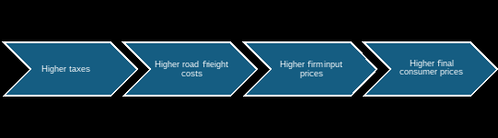
Figure 1 outlines the framework used to consider the supply chain impacts. The analytical methodology utilises the ONS Supply-Use / Input-Output (IO) framework. Fuel duty impacts are estimated as a ‘shock’ that directly impacts Division 24: Coke & refined petroleum products (covers petrol, diesel, aviation fuel, heating oil). Fuel duty is a per-litre excise, so in the IO table it enters as a tax on products within this sector, raising its purchaser’s prices. Other road taxes are incurred via Division 62: Land transport services and transport services via pipelines, excluding rail transport. These supply chain impacts are modelled via a Leontief price model:
where:
- p = vector of price changes,
- A = input–output coefficient matrix,
- v = vector of tax-induced cost increases (i.e., fuel duty applied to petroleum sector).
We start with a shock vector, so for fuel duty impacts, only petroleum products sector has a positive tax shock. This generates a direct rise in the petroleum product’s basic price. Secondly, it generates indirect rises in all other industries that use fuel (transport, retail, food, etc.). These impacts propagate through the system and thereby yields price increases across a wide range of industries.
Microsimulation analysis
The next part of the analysis estimated how these impacts feed through to impact final household prices. This is based on the Living Costs and Food survey data.

Results

The overall impact of a 5p rise in Fuel Duty yields a 0.3 percent increase in overall consumer prices. The impact of a RPI rise in other road taxes (VED and the HGV levy) is much small, at only 0.01%. This is primarily because those road taxes make up a much smaller proportion of overall expenditure on transport.

The main results, broken down by scenario, are presented in Table 1 below.
Table 1: Consumer Price Index (CPI) estimated impacts
2p Fuel Duty rise | 0.1%
5p Fuel Duty rise | 0.3%
2p Fuel Duty rise plus Road Tax RPI rise | 0.1%
5p Fuel Duty rise plus Road Tax RPI rise | 0.3%
Road Tax only | 0.01%

The impact of a 5p fuel duty rise results in a typical motor vehicle owning household spending about £100 more each year, which is about seven percent of total spend on petrol or a month’s worth of an annual household petrol budget. This equates to about £360 per year over the course of the rest of the parliament. These impacts are both felt directly, via higher prices at the pump, but also through higher prices due to costs rising across the supply chain.

Across all households, this amounts to a £1.9bn increase in their annual living costs and £7.3bn over the course of the rest of the parliament. This annual impact exceeds the National Highways capital budget for the financial year 2025 - 2026, which is £1.6 billion in capital funding for local highways maintenance in England. It is also similar to the amount of the Environment Agency's annual expenditure for the financial year ending March 2024, which was £2.2 billion.

The largest household price impacts are to the transport expenditure of household budgets, which makes up about 14% of overall household budgets. There are also significant impacts via supply chains on food and non-alcoholic drinks, which make up about 11% of consumer budgets.

Table 2: Overall spend proportions.
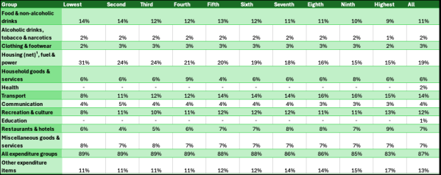
Table 2 above shows the proportion of overall household expenditure spent on different categories of expenditure. This is broken down by the 10 income deciles as well as the overall average (the final column). It shows, for instance, that expenditure on transport items makes up relatively high share of total expenditure (14% on average). However, this share is lower for the lower deciles when compared to household expenditure from households in higher income deciles. This reflects lower rates of car ownership amongst those in lower income deciles.
In contrast, ‘Food and non-alcoholic drinks’ make up relatively higher share of total expenditure for lower income deciles when compared to expenditure shares of those in higher deciles.
Table 3: Comparative price rise impacts (% of total)
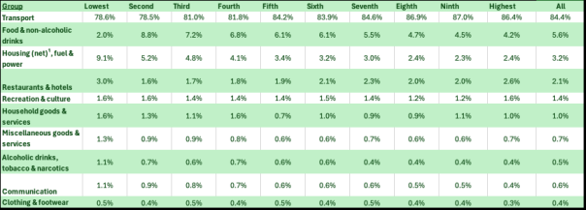
Table 3, above, shows the weighted (by expenditure) inflationary changes for each expenditure group. Each column sums to 100%. It shows that most of the price change as a result of a fuel duty increase is dominated by changes to household transport costs. This is expected as the majority of impacts will be felt directly through increased fuel prices faced by consumers, as increased fuel duty increases petrol and diesel prices at the pump. However, for lower deciles – poorer households – relatively large supply chain impacts are felt via increased food and drink and energy costs. These are particular areas that households have been feeling cost of living pressures in recent years.

Conclusion
An increase in fuel duty is likely to have the most significant impact on final consumer prices via direct increases to petrol prices that households face. There will also be additional price increases as road freight costs to firms increase which will be passed on to consumers via the supply chain.
Whilst this policy will raise revenue for the government, the direct and indirect impacts on consumers via higher prices is likely to be large. A 5p fuel duty increase is estimated to increase overall consumer prices by 0.3%, and overall household annual living costs by almost £2bn. This is equivalent to the budget of a small UK government agency. The cost of living has been a particular challenge of UK households over recent years, and this potential policy change could add fuel to this fire.

52.95 + 10.59 = 63.54.
https://www.racfoundation.org/data/volume-petrol-diesel-consumed-uk-over-time-by-year https://assets.publishing.service.gov.uk/media/685a9f35db207fc18744d608/quarterly-energy-prices-june-2025.pdf
FUEL TAX INCIDENCE AND SUPPLY CONDITIONS – Justin Marion Eric Muehlegger 2011 - https://www.nber.org/system/files/working_papers/w16863/w16863.pdf#:~:text=Fuel%20Tax%20Incidence%20and%20Supply%20Conditions%20Justin%20Marion,predictions%20of%20the%20tax%20incidence%20model%20is%20sparse. Pass-Through, Market Power and Tax Incidence in the Retail Fuel Industry- 2025; CMA - Supply of road fuel in the United Kingdom market study - Final Report 2023 https://assets.publishing.service.gov.uk/media/64a280e845b6a200123d46e7/Supply_of_road_fuel_in_the_United_Kingdom_market_study_Final_Report.pdf
https://www.gov.uk/government/collections/transport-statistics-great-britain https://www.ons.gov.uk/surveys/informationforhouseholdsandindividuals/householdandindividualsurveys/livingcostsandfoodsurvey
This is based on a 2p Fuel Duty (only).

